#
# 20200228
#

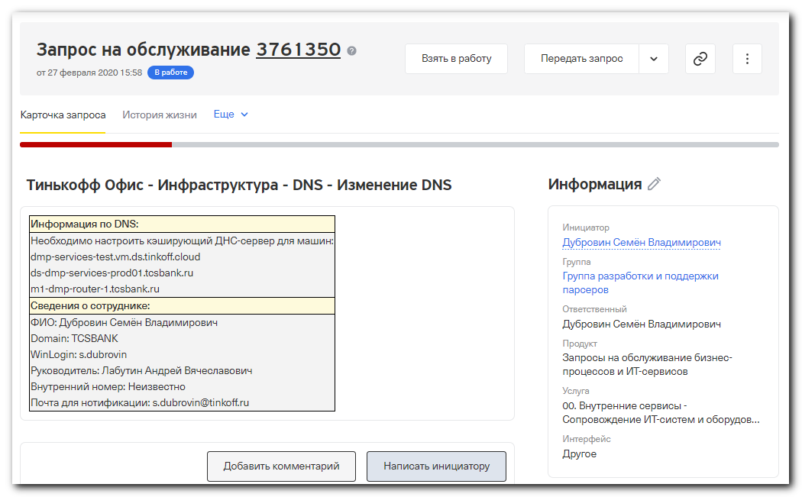

root@ds-dmp-services-prod01:~# cat /etc/os-release
NAME="Ubuntu"
VERSION="16.04.6 LTS (Xenial Xerus)"
ID=ubuntu
ID_LIKE=debian
PRETTY_NAME="Ubuntu 16.04.6 LTS"
VERSION_ID="16.04"
HOME_URL="http://www.ubuntu.com/"
SUPPORT_URL="http://help.ubuntu.com/"
BUG_REPORT_URL="http://bugs.launchpad.net/ubuntu/"
VERSION_CODENAME=xenial
UBUNTU_CODENAME=xenial
root@ds-dmp-services-prod01:~#

root@ds-dmp-services-prod01:~# time timeout 5s tcpdump -nn -c 15 -i any dst host 10.219.50.4 and port 53
tcpdump: verbose output suppressed, use -v or -vv for full protocol decode
listening on any, link-type LINUX_SLL (Linux cooked), capture size 262144 bytes

0 packets captured
4 packets received by filter
0 packets dropped by kernel

real 0m5.037s
user 0m0.000s
sys 0m0.000s
root@ds-dmp-services-prod01:~# time timeout 5s tcpdump -nn -c 15 -i any dst host 10.219.50.5 and port 53
tcpdump: verbose output suppressed, use -v or -vv for full protocol decode
listening on any, link-type LINUX_SLL (Linux cooked), capture size 262144 bytes
08:17:02.252698 IP 10.216.52.51.57288 > 10.219.50.5.53: 47738+ A? stomp1. (24)
08:17:02.252715 IP 10.216.52.51.57288 > 10.219.50.5.53: 61709+ AAAA? stomp1. (24)
08:17:02.253860 IP 10.216.52.51.57288 > 10.219.50.5.53: 47738+ A? stomp1. (24)
08:17:02.253878 IP 10.216.52.51.57288 > 10.219.50.5.53: 61709+ AAAA? stomp1. (24)

4 packets captured
8 packets received by filter
0 packets dropped by kernel

real 0m5.032s
user 0m0.000s
sys 0m0.004s
root@ds-dmp-services-prod01:~#

................................................................................

root@ds-dmp-services-prod01:~# apt-get update
Сущ:1 http://repo-linux.tcsbank.ru/ubuntu xenial InRelease
Сущ:2 http://repo-linux.tcsbank.ru/ubuntu xenial-updates InRelease
Сущ:3 http://repo-linux.tcsbank.ru/ubuntu xenial-backports InRelease
Сущ:4 http://repo-linux.tcsbank.ru/ubuntu xenial-security InRelease
Пол:5 http://repo-linux.tcsbank.ru/puppetlabs/apt xenial InRelease [101 kB]
Пол:6 http://repo-linux.tcsbank.ru/puppetlabs/apt xenial/puppet5 amd64 Packages [44,9 kB]
Получено 146 kB за 0с (154 kB/s)
Чтение списков пакетов… Готово
root@ds-dmp-services-prod01:~# apt-get install unbound
Чтение списков пакетов… Готово
Построение дерева зависимостей
Чтение информации о состоянии… Готово
Будут установлены следующие дополнительные пакеты:
libunbound2 unbound-anchor
Следующие НОВЫЕ пакеты будут установлены:
libunbound2 unbound unbound-anchor
Обновлено 0 пакетов, установлено 3 новых пакетов, для удаления отмечено 0 пакетов, и 57 пакетов не обновлено.
Необходимо скачать 758 kB архивов.
После данной операции объём занятого дискового пространства возрастёт на 2 851 kB.
Хотите продолжить? [Д/н] Y
Пол:1 http://repo-linux.tcsbank.ru/ubuntu xenial-updates/main amd64 libunbound2 amd64 1.5.8-1ubuntu1.1 [244 kB]
Пол:2 http://repo-linux.tcsbank.ru/ubuntu xenial-updates/universe amd64 unbound-anchor amd64 1.5.8-1ubuntu1.1 [25,9 kB]
Пол:3 http://repo-linux.tcsbank.ru/ubuntu xenial-updates/universe amd64 unbound amd64 1.5.8-1ubuntu1.1 [488 kB]
Получено 758 kB за 0с (4 164 kB/s)
Выбор ранее не выбранного пакета libunbound2:amd64.
(Чтение базы данных … на данный момент установлено 114935 файлов и каталогов.)
Подготовка к распаковке …/libunbound2_1.5.8-1ubuntu1.1_amd64.deb …
Распаковывается libunbound2:amd64 (1.5.8-1ubuntu1.1) …
Выбор ранее не выбранного пакета unbound-anchor.
Подготовка к распаковке …/unbound-anchor_1.5.8-1ubuntu1.1_amd64.deb …
Распаковывается unbound-anchor (1.5.8-1ubuntu1.1) …
Выбор ранее не выбранного пакета unbound.
Подготовка к распаковке …/unbound_1.5.8-1ubuntu1.1_amd64.deb …
Распаковывается unbound (1.5.8-1ubuntu1.1) …
Обрабатываются триггеры для libc-bin (2.23-0ubuntu11) …
Обрабатываются триггеры для man-db (2.7.5-1) …
Обрабатываются триггеры для systemd (229-4ubuntu21.23) …
Обрабатываются триггеры для ureadahead (0.100.0-19.1) …
Настраивается пакет libunbound2:amd64 (1.5.8-1ubuntu1.1) …
Настраивается пакет unbound-anchor (1.5.8-1ubuntu1.1) …
Настраивается пакет unbound (1.5.8-1ubuntu1.1) …
Обрабатываются триггеры для libc-bin (2.23-0ubuntu11) …
Обрабатываются триггеры для systemd (229-4ubuntu21.23) …
Обрабатываются триггеры для ureadahead (0.100.0-19.1) …
root@ds-dmp-services-prod01:~#

................................................................................

root@ds-dmp-services-prod01:~# cat /etc/resolv.conf
# Dynamic resolv.conf(5) file for glibc resolver(3) generated by resolvconf(8)
# DO NOT EDIT THIS FILE BY HAND -- YOUR CHANGES WILL BE OVERWRITTEN
nameserver 10.219.50.4
nameserver 10.219.50.5
search tcsbank.ru
root@ds-dmp-services-prod01:~#

................................................................................

root@ds-dmp-services-prod01:~# netstat -nlptu | grep -ie ":53"
root@ds-dmp-services-prod01:~#

root@ds-dmp-services-prod01:~# systemctl status unbound
● unbound.service
Loaded: loaded (/etc/init.d/unbound; bad; vendor preset: enabled)
Drop-In: /run/systemd/generator/unbound.service.d
└─50-insserv.conf-$named.conf, 50-unbound-$named.conf
Active: active (exited) since Пт 2020-02-28 08:16:43 EST; 9min ago
Docs: man:systemd-sysv-generator(8)

фев 28 08:15:52 ds-dmp-services-prod01.tcsbank.ru systemd[1]: Starting unbound.service...
фев 28 08:15:52 ds-dmp-services-prod01.tcsbank.ru unbound[6126]: * Starting DNS server unbound
фев 28 08:15:52 ds-dmp-services-prod01.tcsbank.ru unbound-anchor[6140]: /var/lib/unbound/root.key does not exist, copying from /usr/share/dns/root.key
фев 28 08:16:43 ds-dmp-services-prod01.tcsbank.ru unbound-anchor[6140]: /var/lib/unbound/root.key has content
фев 28 08:16:43 ds-dmp-services-prod01.tcsbank.ru unbound-anchor[6140]: fail: the anchor is NOT ok and could not be fixed
фев 28 08:16:43 ds-dmp-services-prod01.tcsbank.ru unbound[6126]: [1582895803] unbound[6161:0] error: can't bind socket: Cannot assign requested address for ::1
фев 28 08:16:43 ds-dmp-services-prod01.tcsbank.ru unbound[6126]: [1582895803] unbound[6161:0] fatal error: could not open ports
фев 28 08:16:43 ds-dmp-services-prod01.tcsbank.ru unbound[6126]: ...fail!
фев 28 08:16:43 ds-dmp-services-prod01.tcsbank.ru systemd[1]: Started unbound.service.
root@ds-dmp-services-prod01:~#

root@ds-dmp-services-prod01:~# netstat -nlptu | grep -ie ":53"
root@ds-dmp-services-prod01:~# mkdir -p ~/work/20200228-1626
root@ds-dmp-services-prod01:~# cp /etc/unbound/unbound.conf ~/work/20200228-1626/
root@ds-dmp-services-prod01:~# vim /etc/unbound/unbound.conf

root@ds-dmp-services-prod01:~# cat /etc/unbound/unbound.conf
# Unbound configuration file for Debian.
#
# See the unbound.conf(5) man page.
#
# See /usr/share/doc/unbound/examples/unbound.conf for a commented
# reference config file.
#
# The following line includes additional configuration files from the
# /etc/unbound/unbound.conf.d directory.
#include: "/etc/unbound/unbound.conf.d/*.conf"

server:
verbosity: 3
statistics-interval: 0
statistics-cumulative: no
extended-statistics: yes
# num-threads: 8
num-threads: 2
# interface: 0.0.0.0
interface: 127.0.0.1
interface-automatic: yes
msg-cache-size: 128m
msg-cache-slabs: 4
rrset-cache-size: 512m
rrset-cache-slabs: 8
cache-min-ttl: 60
infra-host-ttl: 180
infra-cache-numhosts: 10000
do-ip4: yes
do-ip6: no
do-udp: yes
do-tcp: yes
access-control: 0.0.0.0/0 allow
chroot: ""
username: "unbound"
# logfile: "/var/log/unbound.log"
log-time-ascii: yes
# pidfile: "/var/run/unbound/unbound.pid"
hide-identity: yes
hide-version: yes
harden-glue: yes
harden-dnssec-stripped: yes
harden-below-nxdomain: yes
harden-referral-path: yes
use-caps-for-id: no
unwanted-reply-threshold: 10000000
do-not-query-localhost: no
prefetch: yes
prefetch-key: no
rrset-roundrobin: yes
minimal-responses: yes
module-config: "validator iterator"
# trusted-keys-file: "/etc/unbound/keys.d/*.key"
val-clean-additional: yes
val-permissive-mode: no
val-log-level: 1

local-zone: "10.in-addr.arpa." transparent

local-zone: "16.172.in-addr.arpa." transparent

local-zone: "168.192.in-addr.arpa." transparent

local-zone: "17.172.in-addr.arpa." transparent

local-zone: "18.172.in-addr.arpa." transparent

local-zone: "19.172.in-addr.arpa." transparent

local-zone: "20.172.in-addr.arpa." transparent

local-zone: "21.172.in-addr.arpa." transparent

local-zone: "22.172.in-addr.arpa." transparent

local-zone: "23.172.in-addr.arpa." transparent

local-zone: "24.172.in-addr.arpa." transparent

local-zone: "25.172.in-addr.arpa." transparent

local-zone: "26.172.in-addr.arpa." transparent

local-zone: "27.172.in-addr.arpa." transparent

local-zone: "28.172.in-addr.arpa." transparent

local-zone: "29.172.in-addr.arpa." transparent

local-zone: "30.172.in-addr.arpa." transparent

local-zone: "31.172.in-addr.arpa." transparent

local-zone: "tcsbank.ru." transparent

local-zone: "tinkoff.ru." transparent

remote-control:
control-enable: yes
server-key-file: "/etc/unbound/unbound_server.key"
server-cert-file: "/etc/unbound/unbound_server.pem"
control-key-file: "/etc/unbound/unbound_control.key"
control-cert-file: "/etc/unbound/unbound_control.pem"

forward-zone:
name: "."
forward-addr: 10.219.50.4
forward-addr: 10.219.50.5

root@ds-dmp-services-prod01:~#

root@ds-dmp-services-prod01:~# systemctl stop unbound
root@ds-dmp-services-prod01:~# systemctl start unbound
root@ds-dmp-services-prod01:~# systemctl status unbound
● unbound.service
Loaded: loaded (/etc/init.d/unbound; bad; vendor preset: enabled)
Drop-In: /run/systemd/generator/unbound.service.d
└─50-insserv.conf-$named.conf, 50-unbound-$named.conf
Active: active (running) since Пт 2020-02-28 08:29:37 EST; 19s ago
Docs: man:systemd-sysv-generator(8)
Process: 6552 ExecStop=/etc/init.d/unbound stop (code=exited, status=0/SUCCESS)
Process: 6569 ExecStart=/etc/init.d/unbound start (code=exited, status=0/SUCCESS)
Tasks: 2
Memory: 7.6M
CPU: 91ms
CGroup: /system.slice/unbound.service
└─6588 /usr/sbin/unbound

фев 28 08:29:37 ds-dmp-services-prod01.tcsbank.ru unbound[6588]: [6588:0] debug: target fetch policy for level 4 is 0
фев 28 08:29:37 ds-dmp-services-prod01.tcsbank.ru unbound[6588]: [6588:0] debug: Forward zone server list:
фев 28 08:29:37 ds-dmp-services-prod01.tcsbank.ru unbound[6588]: [6588:0] info: DelegationPoint<.>: 0 names (0 missing), 2 addrs (0 result, 2 avail) parentNS
фев 28 08:29:37 ds-dmp-services-prod01.tcsbank.ru unbound[6588]: [6588:0] debug: cache memory msg=66072 rrset=132120 infra=2632 val=66344
фев 28 08:29:37 ds-dmp-services-prod01.tcsbank.ru unbound[6588]: [6588:0] info: start of service (unbound 1.5.8).
фев 28 08:29:37 ds-dmp-services-prod01.tcsbank.ru unbound[6588]: [6588:1] debug: Forward zone server list:
фев 28 08:29:37 ds-dmp-services-prod01.tcsbank.ru unbound[6588]: [6588:1] info: DelegationPoint<.>: 0 names (0 missing), 2 addrs (0 result, 2 avail) parentNS
фев 28 08:29:37 ds-dmp-services-prod01.tcsbank.ru unbound[6588]: [6588:1] debug: cache memory msg=66072 rrset=132120 infra=2632 val=66344
фев 28 08:29:37 ds-dmp-services-prod01.tcsbank.ru unbound[6569]: ...done.
фев 28 08:29:37 ds-dmp-services-prod01.tcsbank.ru systemd[1]: Started unbound.service.
root@ds-dmp-services-prod01:~# systemctl enable unbound
unbound.service is not a native service, redirecting to systemd-sysv-install
Executing /lib/systemd/systemd-sysv-install enable unbound
root@ds-dmp-services-prod01:~#

root@ds-dmp-services-prod01:~# netstat -nlptu | grep -ie ":53"
tcp 0 0 0.0.0.0:53 0.0.0.0:* LISTEN 6588/unbound
udp 0 0 0.0.0.0:53 0.0.0.0:* 6588/unbound
root@ds-dmp-services-prod01:~#

root@ds-dmp-services-prod01:~# host 10.216.26.19 127.0.0.1 ; host 172.16.1.117 127.0.0.1 ; host repo-linux.tcsbank.ru 127.0.0.1 ; host ya.ru 127.0.0.1 ; host 87.250.250.242 127.0.0.1
Using domain server:
Name: 127.0.0.1
Address: 127.0.0.1#53
Aliases:

19.26.216.10.in-addr.arpa domain name pointer m1-gp-prod-ext.tcsbank.ru.
Using domain server:
Name: 127.0.0.1
Address: 127.0.0.1#53
Aliases:

117.1.16.172.in-addr.arpa domain name pointer vm-vol-nag01t.tcsbank.ru.
117.1.16.172.in-addr.arpa domain name pointer nag-tst.tcsbank.ru.
Using domain server:
Name: 127.0.0.1
Address: 127.0.0.1#53
Aliases:

repo-linux.tcsbank.ru is an alias for ds-repo01.tcsbank.ru.
ds-repo01.tcsbank.ru has address 10.216.42.6
Using domain server:
Name: 127.0.0.1
Address: 127.0.0.1#53
Aliases:

ya.ru has address 87.250.250.242
ya.ru has IPv6 address 2a02:6b8::2:242
ya.ru mail is handled by 10 mx.yandex.ru.
Using domain server:
Name: 127.0.0.1
Address: 127.0.0.1#53
Aliases:

242.250.250.87.in-addr.arpa domain name pointer ya.ru.
root@ds-dmp-services-prod01:~#

................................................................................

#
# It looks like something other has changed /etc/resolv.conf.
#

root@ds-dmp-services-prod01:~# systemctl status systemd-resolved.service
● systemd-resolved.service - Network Name Resolution
Loaded: loaded (/lib/systemd/system/systemd-resolved.service; disabled; vendor preset: enabled)
Drop-In: /lib/systemd/system/systemd-resolved.service.d
└─resolvconf.conf
Active: inactive (dead)
Docs: man:systemd-resolved.service(8)
root@ds-dmp-services-prod01:~#

root@ds-dmp-services-prod01:~# cat /etc/systemd/resolved.conf
# This file is part of systemd.
#
# systemd is free software; you can redistribute it and/or modify it
# under the terms of the GNU Lesser General Public License as published by
# the Free Software Foundation; either version 2.1 of the License, or
# (at your option) any later version.
#
# Entries in this file show the compile time defaults.
# You can change settings by editing this file.
# Defaults can be restored by simply deleting this file.
#
# See resolved.conf(5) for details

[Resolve]
#DNS=
#FallbackDNS=8.8.8.8 8.8.4.4 2001:4860:4860::8888 2001:4860:4860::8844
#Domains=
#LLMNR=yes
#DNSSEC=no
root@ds-dmp-services-prod01:~# ls -Alh /etc/resolv.conf
lrwxrwxrwx 1 root root 29 янв 17 2019 /etc/resolv.conf -> ../run/resolvconf/resolv.conf
root@ds-dmp-services-prod01:~#

................................................................................

#
# https://www.tecmint.com/set-permanent-dns-nameservers-in-ubuntu-debian/
# Other service made changes in /etc/resolv.conf.
#

root@ds-dmp-services-prod01:~# cat /etc/resolv.conf
# Dynamic resolv.conf(5) file for glibc resolver(3) generated by resolvconf(8)
# DO NOT EDIT THIS FILE BY HAND -- YOUR CHANGES WILL BE OVERWRITTEN
nameserver 127.0.0.1
search tcsbank.ru
root@ds-dmp-services-prod01:~#

root@ds-dmp-services-prod01:~# systemctl status resolvconf.service
● resolvconf.service - Nameserver information manager
Loaded: loaded (/lib/systemd/system/resolvconf.service; enabled; vendor preset: enabled)
Active: active (exited) since Ср 2019-12-04 04:54:39 EST; 2 months 25 days ago
Docs: man:resolvconf(8)
Main PID: 527 (code=exited, status=0/SUCCESS)
CGroup: /system.slice/resolvconf.service

Warning: Journal has been rotated since unit was started. Log output is incomplete or unavailable.
root@ds-dmp-services-prod01:~#

root@ds-dmp-services-prod01:~# ls -Alh /etc/resolvconf/
total 12K
-rw-r--r-- 1 root root 511 июн 3 2015 interface-order
drwxr-xr-x 2 root root 4,0K июн 27 2019 resolv.conf.d
drwxr-xr-x 2 root root 4,0K фев 28 08:15 update.d
root@ds-dmp-services-prod01:~# ls -Alh /etc/resolvconf/resolv.conf.d/
total 8,0K
-rw-r--r-- 1 root root 82 янв 18 2019 base
-rw-r--r-- 1 root root 151 июн 3 2015 head
root@ds-dmp-services-prod01:~# cat /etc/resolvconf/resolv.conf.d/head
# Dynamic resolv.conf(5) file for glibc resolver(3) generated by resolvconf(8)
# DO NOT EDIT THIS FILE BY HAND -- YOUR CHANGES WILL BE OVERWRITTEN
root@ds-dmp-services-prod01:~# cat /etc/resolvconf/resolv.conf.d/base
nameserver 10.219.50.4
nameserver 10.219.50.5
domain tcsbank.ru
search tcsbank.ru
root@ds-dmp-services-prod01:~#

#
# I made some changes.
# I've added "nameserver 127.0.0.1".
#
root@ds-dmp-services-prod01:~# vim /etc/resolvconf/resolv.conf.d/base
root@ds-dmp-services-prod01:~# cat /etc/resolvconf/resolv.conf.d/base
nameserver 127.0.0.1
nameserver 10.219.50.4
nameserver 10.219.50.5
domain tcsbank.ru
search tcsbank.ru
root@ds-dmp-services-prod01:~#

root@ds-dmp-services-prod01:~# systemctl restart resolvconf.service
root@ds-dmp-services-prod01:~# systemctl status resolvconf.service
● resolvconf.service - Nameserver information manager
Loaded: loaded (/lib/systemd/system/resolvconf.service; enabled; vendor preset: enabled)
Active: active (exited) since Пт 2020-02-28 08:50:59 EST; 5s ago
Docs: man:resolvconf(8)
Process: 6991 ExecStop=/sbin/resolvconf --disable-updates (code=exited, status=0/SUCCESS)
Process: 7006 ExecStart=/sbin/resolvconf --enable-updates (code=exited, status=0/SUCCESS)
Process: 7004 ExecStartPre=/bin/touch /run/resolvconf/postponed-update (code=exited, status=0/SUCCESS)
Process: 6999 ExecStartPre=/bin/mkdir -p /run/resolvconf/interface (code=exited, status=0/SUCCESS)
Main PID: 7006 (code=exited, status=0/SUCCESS)

фев 28 08:50:59 ds-dmp-services-prod01.tcsbank.ru systemd[1]: Starting Nameserver information manager...
фев 28 08:50:59 ds-dmp-services-prod01.tcsbank.ru systemd[1]: Started Nameserver information manager.
root@ds-dmp-services-prod01:~#

#
# I see no changes...
#
root@ds-dmp-services-prod01:~# cat /etc/resolv.conf
# Dynamic resolv.conf(5) file for glibc resolver(3) generated by resolvconf(8)
# DO NOT EDIT THIS FILE BY HAND -- YOUR CHANGES WILL BE OVERWRITTEN
nameserver 127.0.0.1
search tcsbank.ru
root@ds-dmp-services-prod01:~#

#
# I think I've found - what made content of /etc/resolv.conf.
# Special file, named as unbound, did it.
#
root@ds-dmp-services-prod01:~# ls -Alh /etc/resolvconf/update.d/
total 12K
-rwxr-xr-x 1 root root 4,6K ноя 23 2015 libc
-rw-r--r-- 1 root root 661 июн 7 2018 unbound
root@ds-dmp-services-prod01:~#

root@ds-dmp-services-prod01:~# cat /etc/resolvconf/update.d/unbound
#!/bin/sh -e

PATH=/usr/sbin:/usr/bin:/sbin:/bin

if [ ! -x /usr/sbin/unbound ]; then
exit 0
fi

if [ ! -f /etc/unbound/unbound_control.key ]; then
exit 0
fi

if [ ! -x /lib/resolvconf/list-records ]; then
exit 1
fi

RESOLVCONF_FILES="$(/lib/resolvconf/list-records)"

if [ -n "$RESOLVCONF_FILES" ]; then
NS_IPS="$(sed -rne 's/^[[:space:]]*nameserver[[:space:]]+//p' $RESOLVCONF_FILES \
| egrep -v '^(127\.|::1)' | sort -u)"
else
NS_IPS=""
fi

if [ -n "$NS_IPS" ]; then
FWD="$(echo $NS_IPS | tr '\n' ' ')"
unbound-control forward $FWD 1>/dev/null 2>&1 || true
else
unbound-control forward off 1>/dev/null 2>&1 || true
fi
root@ds-dmp-services-prod01:~#

#
# Ok. I leave it as it is.
#

................................................................................

root@ds-dmp-services-prod01:~# cat /etc/network/interfaces
# This file describes the network interfaces available on your system
# and how to activate them. For more information, see interfaces(5).

source /etc/network/interfaces.d/*

# The loopback network interface
auto lo
iface lo inet loopback
root@ds-dmp-services-prod01:~# cat /etc/network/interfaces.d/ifcfg-eth0
auto eth0
iface eth0 inet static
address 10.216.52.51
netmask 255.255.255.0
gateway 10.216.52.254
root@ds-dmp-services-prod01:~#

................................................................................

root@ds-dmp-services-prod01:~# host repo-linux.tcsbank.ru
repo-linux.tcsbank.ru is an alias for ds-repo01.tcsbank.ru.
ds-repo01.tcsbank.ru has address 10.216.42.6
root@ds-dmp-services-prod01:~# host 10.216.42.6
6.42.216.10.in-addr.arpa domain name pointer ds-repo01.tcsbank.ru.
root@ds-dmp-services-prod01:~#

................................................................................

root@ds-dmp-services-prod01:~# time timeout 5s tcpdump -nn -c 15 -i any dst host 10.219.50.4 and port 53
tcpdump: verbose output suppressed, use -v or -vv for full protocol decode
listening on any, link-type LINUX_SLL (Linux cooked), capture size 262144 bytes
09:03:03.160780 IP 10.216.52.51.29541 > 10.219.50.4.53: 43956+% [1au] A? stomp1.tcsbank.ru. (46)
09:03:03.160904 IP 10.216.52.51.46368 > 10.219.50.4.53: 45250+% [1au] AAAA? stomp1.tcsbank.ru. (46)
09:03:03.161222 IP 10.216.52.51.12299 > 10.219.50.4.53: 8201+% [1au] AAAA? stomp1. (35)
09:03:03.161283 IP 10.216.52.51.32197 > 10.219.50.4.53: 22543+% [1au] A? stomp1. (35)
09:03:03.164867 IP 10.216.52.51.21647 > 10.219.50.4.53: 44116+% [1au] AAAA? stomp1. (35)
09:03:03.166227 IP 10.216.52.51.34465 > 10.219.50.4.53: 2041+% [1au] AAAA? stomp1. (35)
09:03:03.166361 IP 10.216.52.51.42461 > 10.219.50.4.53: 60031+% [1au] A? stomp1. (35)
09:03:03.166605 IP 10.216.52.51.51449 > 10.219.50.4.53: 39229+% [1au] A? stomp1. (35)
09:03:03.166914 IP 10.216.52.51.8782 > 10.219.50.4.53: 7062+% [1au] A? stomp1. (35)
09:03:03.170072 IP 10.216.52.51.22414 > 10.219.50.4.53: 52787+% [1au] A? stomp1. (35)
09:03:03.171233 IP 10.216.52.51.18555 > 10.219.50.4.53: 59414+% [1au] AAAA? stomp1. (35)
09:03:03.182104 IP 10.216.52.51.5738 > 10.219.50.4.53: 18413+% [1au] AAAA? stomp1. (35)

12 packets captured
16 packets received by filter
0 packets dropped by kernel

real 0m5.039s
user 0m0.000s
sys 0m0.000s
root@ds-dmp-services-prod01:~# time timeout 5s tcpdump -nn -c 15 -i any dst host 10.219.50.5 and port 53
tcpdump: verbose output suppressed, use -v or -vv for full protocol decode
listening on any, link-type LINUX_SLL (Linux cooked), capture size 262144 bytes

0 packets captured
0 packets received by filter
0 packets dropped by kernel

real 0m5.032s
user 0m0.000s
sys 0m0.000s
root@ds-dmp-services-prod01:~#

https://www.tecmint.com/set-permanent-dns-nameservers-in-ubuntu-debian/

How To Set Permanent DNS Nameservers in Ubuntu and Debian
by Aaron Kili | Published: October 11, 2019 | October 11, 2019
Linux Certifications - RHCSA / RHCE Certification | Ansible Automation Certification | LFCS / LFCE Certification
The /etc/resolv.conf is the main configuration file for the DNS name resolver library. The resolver is a set of functions in the C library that provide access to the Internet Domain Name System (DNS). The functions are configured to check entries in the /etc/hosts file, or several DNS name servers, or to use the host’s database of Network Information Service (NIS).
On modern Linux systems that use systemd (system and service manager), the DNS or name resolution services are provided to local applications via the systemd-resolved service. By default, this service has four different modes for handling the Domain name resolution and uses the systemd DNS stub file (/run/systemd/resolve/stub-resolv.conf) in the default mode of operation.
The DNS stub file contains the local stub 127.0.0.53 as the only DNS server, and it is redirected to the /etc/resolv.conf file which was used to add the name servers used by the system.
If you run the following ls command on the /etc/resolv.conf, you will see that this file is a symlink to the /run/systemd/resolve/stub-resolv.conf file.
$ ls -l /etc/resolv.conf

lrwxrwxrwx 1 root root 39 Feb 15 2019 /etc/resolv.conf -> ../run/systemd/resolve/stub-resolv.conf

Unfortunately, because the /etc/resolv.conf is indirectly managed by the systemd-resolved service, and in some cases by the network service (by using initscripts or NetworkManager), any changes made manually by a user can not be saved permanently or only last for a while.
In this article, we will show how to install and use the resolvconf program to set permanent DNS name servers in /etc/resolv.conf file under Debian and Ubuntu Linux distributions.

Why Would You Want to Ddit /etc/resolv.conf File?
The main reason could be because the systems DNS settings are misconfigured or you prefer to use specific name servers or your own. The following cat command shows the default name server in the /etc/resolv.conf file on my Ubuntu system.
$ cat /etc/resolv.conf

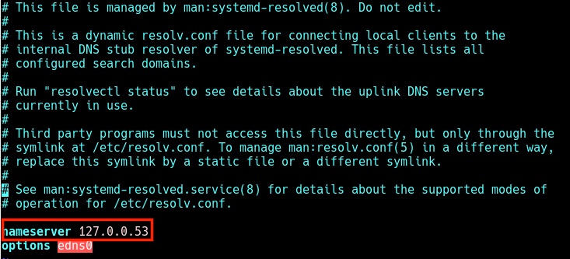
Check DNS Name Servers
In this case, when local applications such as the APT package manager try to access FQDNs (Fully Qualified Domain Names) on the local network, the result is a “Temporary failure in name resolution” error as shown in the next screenshot.
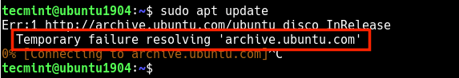
Temporary Failure Resolving
The same happens when you run a ping command.
$ ping google.com


Temporary Failure in Name Resolution
So when a user tries to manually set the name servers, the changes do not last for long or are revoked after a reboot. To resolve this, you can install and use the reolvconf utility to make the changes permanent.
To install the resolvconf package as shown in the next section, you need to first of all manually set the following name servers in the /etc/resolv.conf file, so that you access the FQDMs of Ubuntu repository servers on the internet.
nameserver 8.8.4.4
nameserver 8.8.8.8

Read Also: How to Setup Local DNS Using /etc/hosts File in Linux

Installing resolvconf in Ubuntu and Debian
First, update the system software packages and then install resolvconf from the official repositories by running the following commands.
$ sudo apt update
$ sudo apt install resolvconf

Once the resolvconf installation is complete, systemd will trigger the resolvconf.service to be automatically started and enabled. To check if it is up and running issues the following command.
$ sudo systemctl status resolvconf.service

If the service is not started and enabled automatically for any reason, you can start and enable it as follows.
$ sudo systemctl start resolvconf.service
$ sudo systemctl enable resolvconf.service
$ sudo systemctl status resolvconf.service

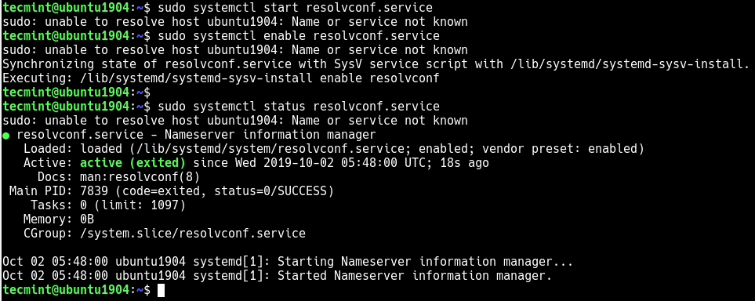
Check Resolvconf Service Status

Set Permanent DNS Nameservers in Ubuntu and Debian
Next, open the /etc/resolvconf/resolv.conf.d/head configuration file.
$ sudo nano /etc/resolvconf/resolv.conf.d/head

and add the following lines in it:
nameserver 8.8.8.8
nameserver 8.8.4.4

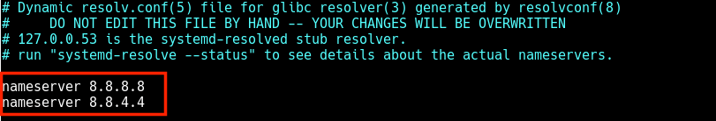
Set Permanent DNS Name Servers in Resolvconf
Save the changes and restart the resolvconf.service or reboot the system.
$ sudo systemctl start resolvconf.service

Now when you check the /etc/resolv.conf file, the name server entries should be stored there permanently. Henceforth, you will not face any issues concerning name resolution on your system.
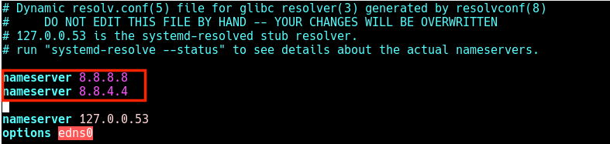
Permanent DNS Name Servers
I hope this quick article helped you in setting the permanent DNS nameservers in your Ubuntu and Debian systems. If you have any queries or suggestions, do share it with us in the comments section below.

